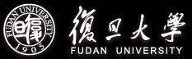

2025 Shanghai Summer School: Comparative Governance Program for Neighboring Countries

School of International Relations and Public Affairs
Fudan University, China
June 3 – 20, 2025

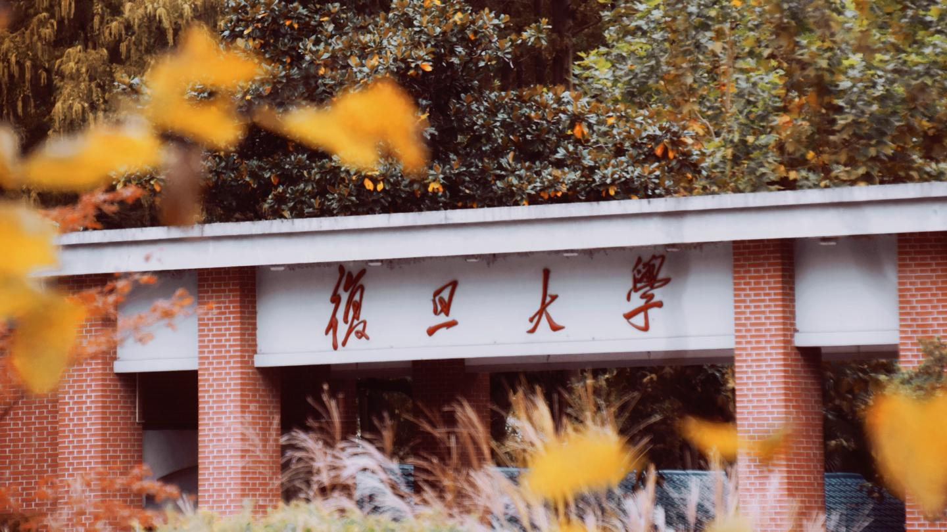

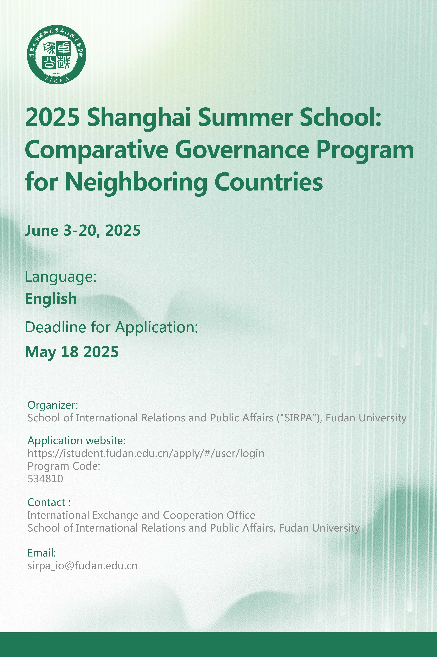
Organizer
2025 Shanghai Summer School: Comparative Governance Program for Neighboring Countries (the “Program”) is sponsored by Shanghai Municipal Education Commission and organized by School of International Relations and Public Affairs (“SIRPA”), Fudan University.

Introduction
Since July 2017, SIRPA has jointly launched the Advanced Training Program for Young Diplomatic Talents from Belt and Road Countries. As of 2024, seven cohorts have been held, enrolling a total of 97 participants from 42 Belt and Road countries. Commissioned by the Shanghai Municipal People’s Government and the Shanghai Municipal Education Commission, this program serves as a key strategic initiative to support the Belt and Road Initiative. It aims to strengthen people-to-people ties between young diplomats, civil servants, and social elites from Belt and Road countries and China, and to deepen their understanding of China’s development strategy and Shanghai’s role in global urban governance.

The 2025 Shanghai Summer School: Comparative Governance Program for Neighboring Countries is an extension of this initiative. The program maintains a sustained focus on the theme of Consensus, Co-prosperity, and Sharing, aligning with the internationalization strategy of China’s Double First-Class Initiative and the development of political science as a leading discipline. It also constitutes an innovative model of disciplinary collaboration, in which local youth scholars and students are jointly recruited by partner institutions, leading faculty members from the SIRPA are assigned to deliver instruction, and academic exchange between Fudan’s political science scholars and their counterparts in neighboring countries is significantly broadened.

Curriculum
The curriculum is comprised of five modules: Chinese modernization ‌&
Chinese Governance System, Chinese Development and Global Governance, Chinese Diplomacy and Construction of a Community with a Shared Future, National Conditions of Belt and Road & Neighboring Countries, and Inheritance and Modernization of Chinese Culture. The Program takes the form of lectures, seminars and workshops. Leading experts, senior diplomats and practical specialists may be invited. The working language of the Program is English.

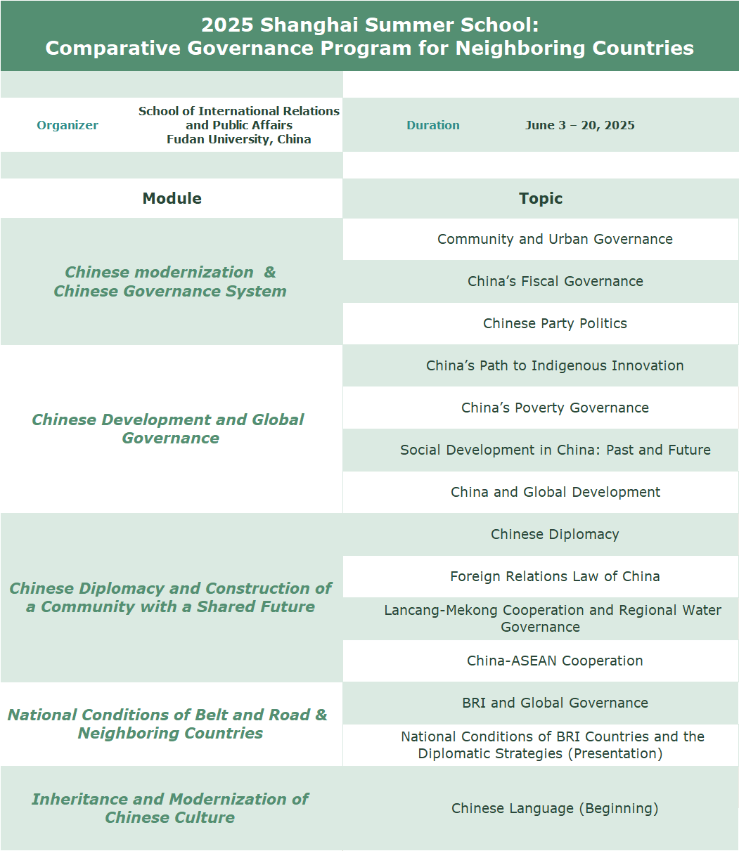
*Tentative

Duration
June 3 – 20, 2025 (no class at weekends)
Teaching Venue
Handan Campus, Fudan University

Application
- Qualification
Young talents from Neighboring Countries & Countries Involved in the Belt and Road Initiative, including but not limited to those signed MOUs with China. General interest and educational background in international politics is a must, and work experience in diplomacy is preferred in consideration. Applicants should be under the age of 40.
- Online Application Procedure
- Please log onto the website (https://istudent.fudan.edu.cn/apply/#/user/login) to complete the online application (application fee of 400 RMB must be paid to complete the application).
Program Code: 534810
- Please also send the digital version of the system-required documents in a compressed file to sirpa_io@fudan.edu.cn in the format of 2025 SHANGHAI SUMMER SCHOOL + FULL NAME + COUNTRY
- Application form (downloaded from the online application website and signed by the applicant)
- Degree certificate of previous education or studying certificate (for applicant in the final year of study)
- Passport (personal information page)
- Personal Statement in English (no more than 1,000 words, within one page)
- Resume
- English Transcript
- 2025 Program_Applicant (downloaded below)
- Deadline for Application
May 18, 2025
- Admission
Enrollment: 20 participants
Shortlisted candidates will be informed via email by May 23, 2025

Financial Support
The program tuition fee will be fully covered by the Shanghai Government Scholarship.
Accommodation and transportation costs need to be paid by the participants themselves. Fudan university offers on-campus housing options, which are more affordable than market rates.

Certificate of Completion
A Certificate of Completion will be awarded to participants with full attendance and good performance.

Contact
International Exchange and Cooperation Office, School of International Relations and Public Affairs, Fudan University
Email: sirpa_io@fudan.edu.cn

Download: 2025_Enrollment_Shanghai_Summer_School_Comparative_Governance_Program.xlsx

